AICAD Adjunct Research Portal Blueprint
1. Project Overview
The Adjunct Research Portal is a web-based platform developed using Django that enables institutions to manage adjunct researchers, research applications, publications, grants, and researcher profiles.
The platform provides:

- Researcher registration and authentication
- Adjunct researcher application workflow
- Researcher directory
- Research profile management
- Publications and achievements management
- Search and pagination
- Admin approval system
- Google authentication
- Email verification

2. System Users
2.1 Guest Users
Guests can:

- View approved adjunct researchers
- Search researchers
- View researcher details
- Signup
- Login
- Login using Google

2.2 Registered Researchers
Researchers can:

- Edit their profile
- Upload profile picture
- Add research area
- Add institution
- Add publications
- Add work experience
- Add grants/fellowships
- Upload CV
- Upload application letter
- Update achievements
- Track proposal applications
- Track proposal wins
- Apply to become adjunct researchers

2.3 Administrators
Administrators can:

- Approve adjunct researchers
- Reject applications
- Add researchers manually
- Manage users
- Manage publications
- View uploaded CVs and application letters
- Manage site content
- View statistics

3. Main Modules
3.1 Authentication Module
Features

- Signup
- Login
- Logout
- Password confirmation
- Email verification
- Google authentication
- Session management

Technologies
- Django Authentication
- django-allauth
- Gmail SMTP
3.2 Researcher Profile Module
Profile Information

- Prefix (Mr., Dr., Prof., etc.)
- First name
- Last name
- Email
- Profile picture
- Institution
- Research area
- Brief profile
- Work experience
- Grants/Prizes/Fellowships
- Publications
- Achievements
- Proposals applied
- Proposals won

Uploads
- CV upload
- Application letter upload
Rich Text Editing
- CKEditor integration
3.3 Adjunct Researcher Directory
Features | Search Criteria | Pagination
Public researcher listing | Name | 9 entries per page
Search functionality | Research area
Pagination | Institution
Researcher detail pages | Publications
Profile viewing

3.4 Researcher Details Page
Sections

- Profile overview
- Research area
- Work experience
- Publications
- Grants/Fellowships
- Achievements
- Proposal statistics

3.5 Admin Management Module
Admin Functions

- Approve researchers
- Reject applications
- Manage uploaded files
- Add researchers manually
- Edit profiles
- Delete profiles
- Manage publications

4. Database Design
4.1 User Table
Stores:

- Username
- Email
- Password
- Authentication information

4.2 ResearcherProfile Table
Stores:

- User relationship
- Profile picture
- Institution
- Research area
- Achievements
- Proposal counts
- Adjunct approval status
- CV
- Application letter

4.3 Publication Table
Stores:

- Publication title
- Description
- Publication date
- Researcher relationship

5. Site Navigation Structure
Public Navigation

- Home
- Researchers
- Login
- Signup
- Google Login

Authenticated Navigation

- Home
- Researchers
- Profile
- Edit Profile
- Logout

6. User Workflow
Researcher Signup Workflow

- User signs up
- Email verification sent
- User verifies email
- Research profile created automatically
- User logs in
- User updates profile
- User uploads CV and application letter
- Admin reviews application
- Admin approves researcher
- Researcher appears in public directory

7. Frontend Design
Technologies

- HTML5
- Bootstrap 5
- CSS3
- CKEditor

UI Features

- Responsive design
- Fixed navigation bar
- Search interface
- Pagination controls
- Researcher cards
- Mobile-friendly layout

8. Backend Technologies
Core Stack

- Python
- Django
- SQLite (Development)
- PostgreSQL (Production Recommended)

Additional Packages

- django-allauth
- django-ckeditor
- Pillow
- requests
- PyJWT

9. File Structure

adjunct_portal/
│
├── accounts/
│ ├── models.py
│ ├── views.py
│ ├── urls.py
│ ├── forms.py
│ ├── admin.py
│ ├── signals.py
│ └── templates/
│
├── config/
│ ├── settings.py
│ ├── urls.py
│ └── wsgi.py
│
├── templates/
│ ├── base.html
│ ├── signup.html
│ ├── login.html
│ ├── profile.html
│ ├── edit_profile.html
│ ├── adjunct_researchers.html
│ └── researcher_detail.html
│
├── media/
│ ├── profile_pictures/
│ ├── cvs/
│ └── application_letters/
│
├── static/
│ ├── css/
│ ├── js/
│ └── images/
│
└── manage.py

10. Security Features

- Password hashing
- CSRF protection
- Email verification
- Secure authentication
- Protected researcher editing
- Login-required pages

11. Current Features Completed
Completed

- Signup page
- Login page
- Google authentication
- Email verification
- Researcher profiles
- Edit profile
- CKEditor integration
- Search system
- Pagination
- Public researcher directory
- Researcher details page
- Profile picture uploads
- CV uploads
- Application letter uploads
- Admin approval system

12. Future Enhancements
Recommended Next Features

- Research proposal management
- Messaging system
- Notifications
- Research collaboration requests
- Dashboard analytics
- PDF profile export
- Publication DOI integration
- API development
- Advanced filtering
- Research categories
- Institution management
- Research funding tracker

13. Deployment Recommendations
Production Stack

- Ubuntu 22.04
- PostgreSQL / MongoDB
- Gunicorn
- Nginx
- Linux Server
- SSL Certificate
- Cloud storage for uploads

Suggested Hosting

- Render
- Railway
- DigitalOcean
- AWS
- HostAfrica

14. Updated Data Flow Diagram (DFD)
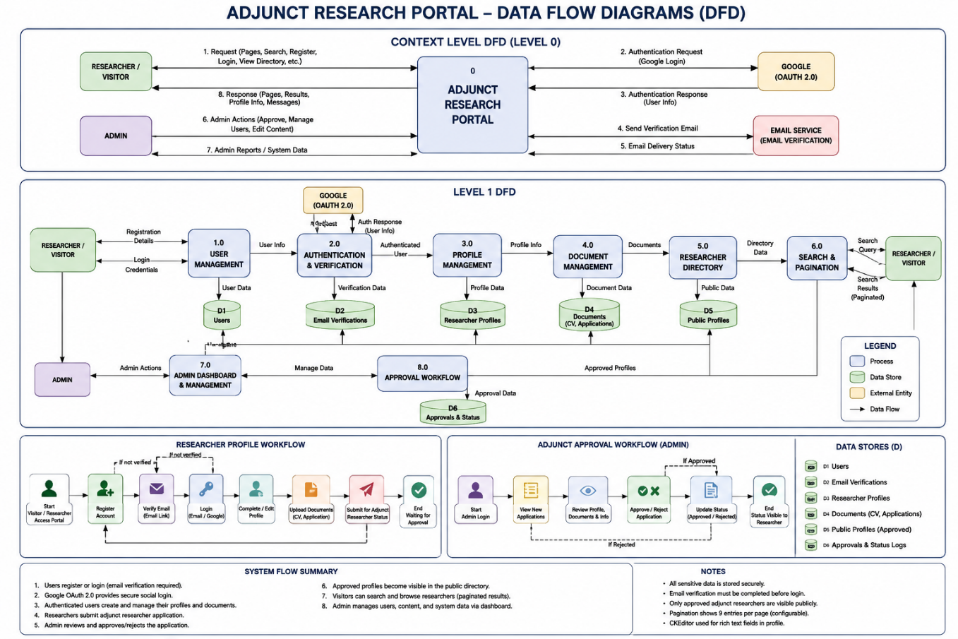
14.5 Updated System Flow Summary
Main System Flows

- User Registration Flow
- Login & Authentication Flow
- Profile Management Flow
- Publication Management Flow
- Research Application Workflow
- Admin Approval Workflow
- Public Directory Search Workflow
- Google Authentication Workflow
- Email Verification Workflow

15. Conclusion
The Adjunct Research Portal provides a scalable and professional system for managing adjunct researchers, research applications, publications, and institutional collaborations.
The architecture supports future expansion while already providing a strong foundation for academic and research management workflows.

